VIVA AFRICA 2019
Practical Information

FLIGHT OPTIONS
The closest international airports are listed below. However, the majority of international visitors arrives at the airport in Prague or in Vienna.
- Brno – Airport Tuřany (70 km)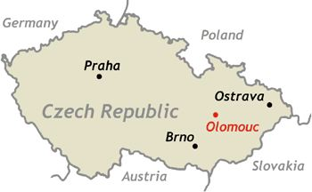
- Ostrava – Leoš Janáček Airport in Mošnov (80 km)
- Katowice – Katowice-Pyrzowice (210 km)
- Bratislava – M. R. Štefánik Airport (210 km)
- Vienna – Vienna International Airport (260 km)
- Krakow – Kraków-Balice (265 km)
- Praha – Václav Havel Airport Ruzyně (280 km)

From Václav Havel airport Prague to Olomouc
- By bus from Prague airport to Prague main train station
The easiest way to get from the Václav Havel Airport Prague to the main train station (Praha, Hlavní nádraží), is to take the Airport Express (AE) bus. It stops right in front of the arrival hall and terminates at the main train station. The ticket costs CZK 60 and it must be purchased from the bus driver.
- By Train from Prague main train station to Olomouc
Trains are currently the fastest way to get to Olomouc from Prague, because of the ongoing reconstruction of the highway, busses could be quite delayed.
There is an option to choose between the state-run České dráhy (Czech Railways), or private-run RegioJet and Leo Express. However, purchased ticked from one company cannot be used for trains owned by the other two. Price for one-way ticket varies, but it is usually around CZK 200-300,-Kč. The journey from Prague to Olomouc takes approximately 2.5 hours (Pendolino 2 hours). Tickets can be purchased online or at the train station.
Timetable and online booking:
- České dráhy – www.cd.cz
- RegioJet – www.regiojet.cz
- Leo Express – www.le.cz
From Vienna Airport to Olomouc
There is a direct minibus connection by company Tiger Express, going from the Vienna Airport to Olomouc railway station three times a day for CZK 599.
You can also take the Student Agency coach, which goes from the Vienna Airport via Brno to Olomouc main train station (5 times daily). The ticket costs around CZK 425.
Tickets can be purchased here
VISITING OLOMOUC
Getting to the conference venue:
The route from Olomouc Main Train Station or the Olomouc Bus Terminal to the venue of the conference can be viewed on the map below.

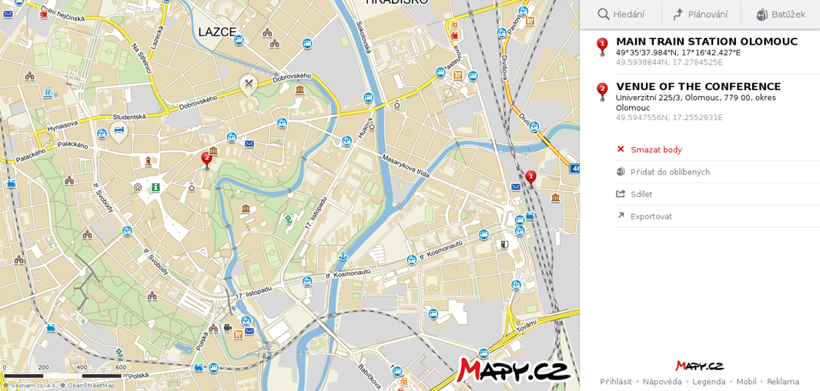

Travelling within Olomouc
There is a dense network of public transportation in Olomouc, which includes busses and trams. Timetable can be viewed here.
Ticket can be purchased from vending machines and newspaper stands. It costs CZK 14, and is valid for 40 minutes during weekdays and 60 minutes during weekends and holidays. Ticket can be also purchased from the bus/tram driver, but the price is CZK 20. There is also an option to buy one-day ticket for CZK 46.
Ticket can be purchased via mobile phone with Czech number, just by sending text “DPMO” to 902 06 (ticket is valid for 50 minutes and costs CZK 18 plus fee for service provider).
Accommodation
Below there is a list of recommended accommodation in Olomouc, divided into three groups regarding the quality of accommodation and prices. All the places are conveniently located near the city center and not far from the faculty building. Rates for single bedroom vary from about 15 EUR per night up to 150 EUR.
Room availability and rates can be checked here
Category 60 – 100 EUR
- Hotel NH Congress**** 80€
- Hotel Trinity**** 75€
- Hotel Clarion**** 70€
- Hotel Arigone***/**** 70€
- Hotel Alley**** 57€
- Hotel Ibis*** 50€
Category 26 – 59 EUR
- Pension Angelus 50€
- Pension Křivá**** 50€
- Hotel v Ráji**** 48€
- Pension na Hradě**** 45€
- Pension U Jakuba*** 45€
- Hotel Flóra***/**** 37€
- Pension Bellis 37€
Low budget accomodation 10 – 27 EUR
- Cosy Corner Hostel 12-27€
- Palacký University Dormitory 13€
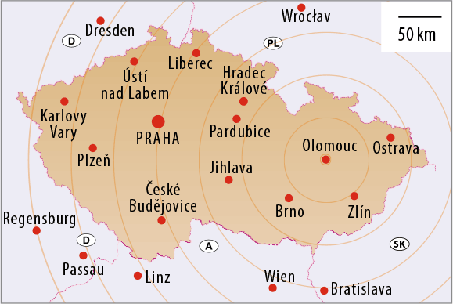
VIVA AFRICA 2019
11th International Conference on African Studies
Multiple Entanglements in African Politics
November 28 ̶ 29, 2019 / Olomouc / Czech Republic
For more information visit www.vivaafrica.cz www.africanstudies.cz

